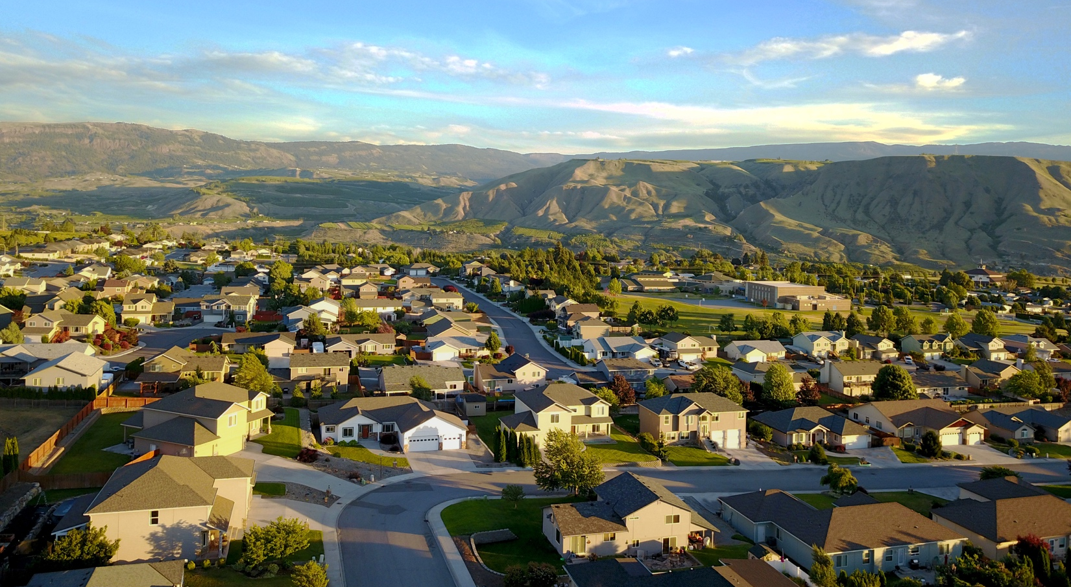

Specially Prepared For

John Doe
321 Elm St.
Wenatchee, WA 98801

Prepared by
Contractor Name
email@website.com
(555) 555-5555

Month XX, Year

CONTRACTOR STATEMENT
The following project measures have been designed and formulated specifically for your home. Contractor Name is committed to finding the best ways to make your home more energy efficient and comfortable.

WHOLE HOME AIR SEALING
$X,XXX

- Perform Blower Door Guided air sealing.
- Seal accessible plumbing and electrical penetrations between conditioned and unconditioned spaces.
- Prioritize sealing connections to the attic and crawlspace/basement for better interior air quality and moisture control.
- Air sealing measure will be completed to local utility Air Sealing specifications.

Available rebates: $XX.XX (not deducted from price shown)

DUCT SEALING AND INSULATION
$X,XXX

- All accessible portions of the duct system shall be repaired, mechanically fastened and sealed where applicable.
- Insulate ductwork with R-19 formaldehyde-free fiberglass insulation with vinyl backing.
- All accessible connections to be inspected and repaired to local utility specifications.

Available rebates: Up to $XX.XX (not deducted from price shown)

FLOOR INSULATION
$X,XXX

- Install 839 sq. ft. of R-19 formaldehyde-free fiberglass insulation batts in crawlspace ceiling and twine in place for continuous contact to heated floor for increase comfort.
- Final R-value to be R-30.
- Insulate and weatherstrip crawlspace hatch.
- Install 6-mil polyethylene ground barrier on crawlspace floor to reduce moisture and particle intrusion.
- Install (1) new foundation vent for proper ventilation per code.
- Drill and Fill 133 sq. ft. of cantilever with fiberglass blown to R-25.
- All items to be installed to BPA and local utility specifications.
- Plumbing and ducts to be inspected for leaks and disrepair. Any newly found problems will be communicated to homeowner and an estimate may be provided to undertake corrective work.

Available rebates: $XX.XX (not deducted from price shown)

ATTIC INSULATION
$X,XXX

- Remove existing insulation and dispose/recycle debris.
- Dam around attic hatch with ½” plywood, weatherstrip and insulate hatch with rigid foam board insulation to R-30.
- Install baffles at existing lower eave vents.
- Baffle around existing bath fan. Install insulated hard duct and connect to new dedicated exterior termination with damper.
- Install (1) new metal 8” RV50 roof vent per code.
- Install 839 sq. ft. of blown-in formaldehyde-free fiberglass insulation to R-49.

Available rebates: $XX.XX (not deducted from price shown)

WALL INSULATION
$X,XXX

1st Floor
- Remove siding as necessary for wall insulation installation on 1st floor.
- Install 1355 sq. ft of dense packed formaldehyde-free fiberglass insulation to R-15 in 1st floor walls.
- Weather seal, and reinstall original siding. Repair walls with new plugs and texture to blend as close as possible with existing texture.
- No painting included.
2nd Floor
- Install dust protection as necessary for interior wall insulation installation in 2nd floor walls.
- Install 738 sq. ft. of dense packed formaldehyde-free fiberglass insulation to R-15 in 2nd floor walls.
- Repair walls with new plugs and texture to blend as close as possible with existing texture.
- No painting included.

Available rebates: $XX.XX (not deducted from price shown)

BRAND AIR SOURCE HEAT PUMP
$X,XXX

- Remove and properly dispose/recycle existing heat pump air handler, outside unit, and refrigerant lines.
- Furnish and install the new 3 ton XP25 modulating compressor heat pump with air handler and variable speed fan motor.
- 10 HSPF/ 22 SEER efficiency
- Fabricate and install sheet metal fittings to accommodate furnace.
- Furnish and install new PVC venting and combustion air intake to exterior.
- Furnish and install condensate pump.
- Start up, test, and adjust equipment to PTCS and local utility specifications and requirement for optimal efficiency.
- Required HVAC permit included.
- 10-year limited warranty
- Also Included: Provide and install MERV 12 air purification system at time of install.

Available rebates: $XX.XX (not deducted from price shown)

BRAND HEAT PUMP WATER HEATER
$X,XXX

- Drain, remove and dispose/recycle existing hot water heater.
- Install new rebate qualifying 50-gallon Brand Heat Pump Water Heater.
- Install needed duct to exterior, drain line, seismic strapping, drain pan and T&P valve.
- Connect water heater to existing electrical.
- Install new plumbing connections and connect to existing water lines.
- Permit included.
- Water Heater to be installed to manufacturer and local utility specifications.
- 10-year limited warranty.

Available rebates: $XX.XX (not deducted from price shown)

Total Investment Price:
$X,XXX

Utility Rebates and Incentives:
$X,XXX

Available Tax Credit:
$X,XXX

Total Price:
$X,XXX or $XX.XX/month

I accept this proposal

___________________________________
Homeowner

Project Also Includes: Preparation of your home for dust protection and safety | Careful removal of existing attic and floor insulation | Disposal/recycling fees | Lead Testing (if Lead is found a change order for proper removal may be required) | Delivery of materials | Professional installation by Contractor Name’s trained installers | 3-year installation warranty

Rebates, Incentives and Tax Credits: Rebates are estimated based on your local utility’s offerings. Incentives and tax credits are estimates and are not guaranteed based on your personal tax liability.

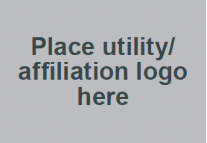
Contractor Name
123 Main St.
Wenatchee, WA 98801
(555) 555-5555

